BACK-END DEVELOPMENT

# 

**Table of Contents**

1. Introduction 3

2. Website Functionality and Features 3

3. Technical Implementation 6

4. Development Process 7

5. Evaluation of Technologies Used 8

6. Conclusion 8

Reference List 9

# 1. Introduction

The implementation of a database management system for St Alphonsus Primary School will effectively eliminate the issues posed by paperwork for the management of information of pupils, teachers, classes, and parents. The main goal of this system is to ensure that there is an interface dimension that will enable authorized officers to type and search for data easily. Our technology stack is PHP for server-side scripting and MySQL for database management, with proper emphasis on the security and scalability of the data storage. The proposed digitization of the school’s records can help minimize errors and increase access to records for better decision-making in the school. The necessary primitive functions consist of data addition and access view functions so that the users can easily use the system. This means that through the web base design of the application, the staff members will be in a position to use the system on different apparatus without having to download and install the software. This report contains information about the details of the system, how it has been created and the technologies that have been employed.

## 2. Website Functionality and Features

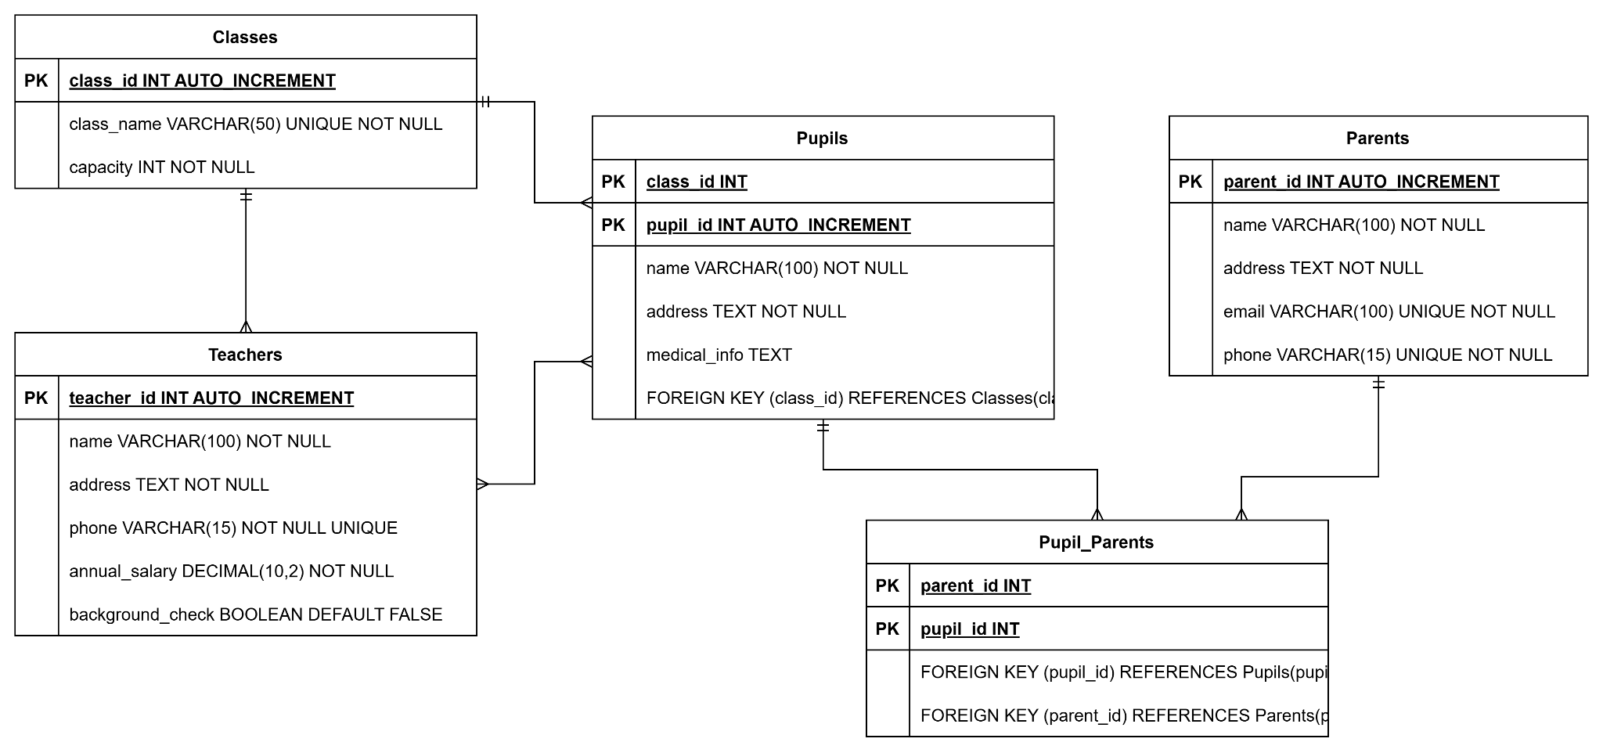

**Figure 1: ERD of the System**

(Source: Made by self in draw.io)

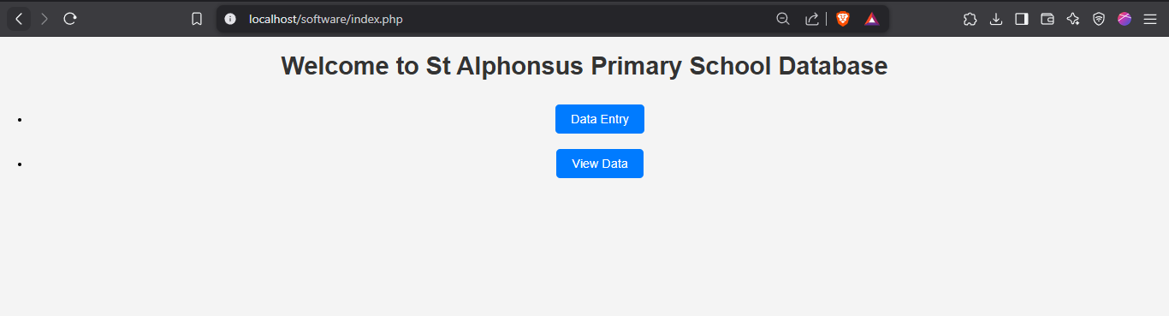

**Figure 2: Home page of the Data entry system**

(Source: Made by self in VS Code)

This website has three parts, which are the Homepage, the Data Entry Page and the View Data Page. The Home Page is a main screen through which a user enters the system and has a simple way of navigating. To match with what has already been explained, the options that are given to the users are two, namely; Data Entry and View Data (Huang and Bringula, 2023). The concepts displayed on the Home Page make it possible for the users of the system to have easy and shortcut time access to the main features of the system regardless of their level of computer literacy. On the same page, clicking on the "Data Entry" link leads the users to a part of the website designed for entering data into the database.

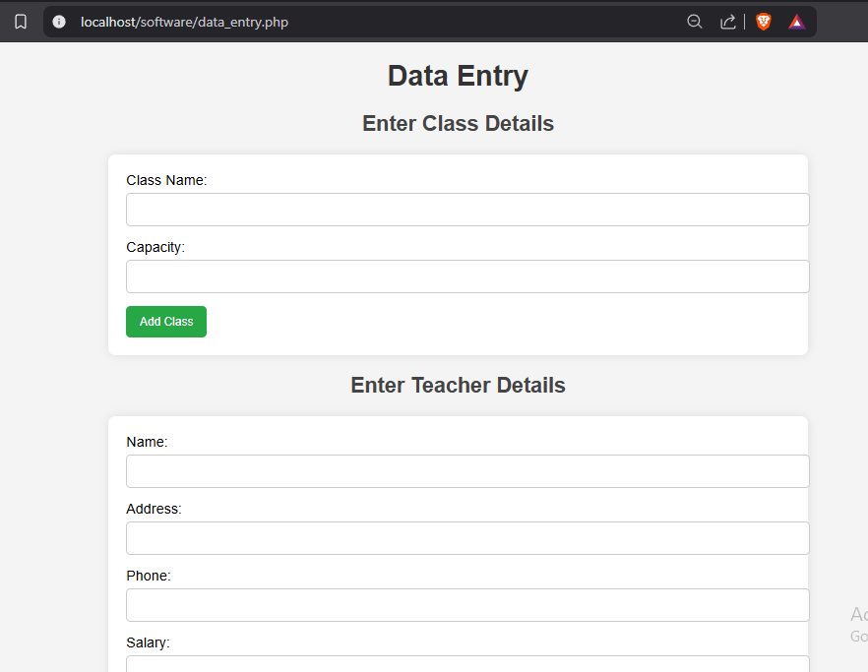

**Figure 3: Data entry page**

(Source: Made by self in VS Code)

The Data Entry Page will enable the input of vital information important to the functioning of the school. This page consists of forms that deal with the input in each of the major tables which include the Classes table, Pupils table, Parents table, and the Teachers table. Each of them has fields adjusted to the related table for structured data entry. For example, the Class form enables users to put in the class name and number of students allowed while the Pupil form is used to input the student's information such as physical location, and medical history among others. Details such as background checks and salary expectations about the teacher being recruited.

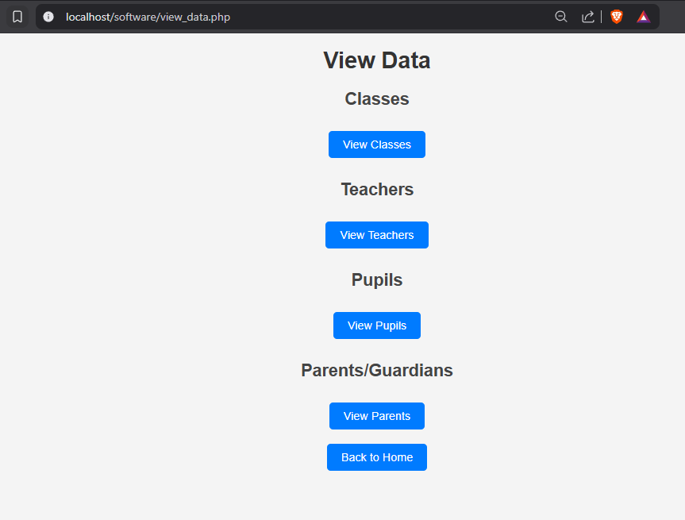

**Figure 4: View Data page**

(Source: Made by self in VS Code)

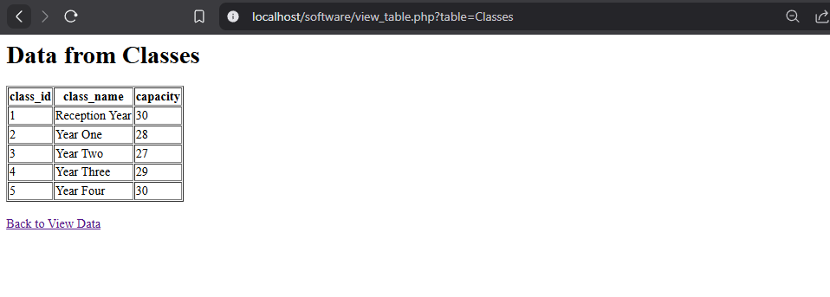

**Figure 5: Viewing tables**

(Source: Made by self in VS Code)

The View Data Page is a friendly and convenient page to help school administrators retrieve the stored records easily. The buttons on this page are also labeled in the form of tables to display related data in an organized way involving the use of a table. The information displayed within the system is pulled from the design unfolded about the MySQL database clearly and efficiently. They are identities including names, addresses, class assignments, and teachers among other qualities that necessitate the use of every table.

# 3. Technical Implementation

Technologically the St Alphonsus Primary School database system is developed by using PHP for server-side script and MySQL for administrative duties. PHP is used for getting values from the form, submitting forms and performing other database operations by writing SQL statements. In this system, the MySQL extension is used to connect PHP and MySQL databases for the secure transfer of data (Hidayat, 2020). Data retrieval is done through the SELECT operations which enable the retrieval of records from the database and displaying them in the View Data Page. Input validation is applied to avoid SQL injection by using the 'mysqli_real_escape_string ()' function to clean the data entered by the user. This makes it easy to access and store information while the structure of the database adopted is relational, thus making the database-less susceptible to data redundancy.

# 4. Development Process

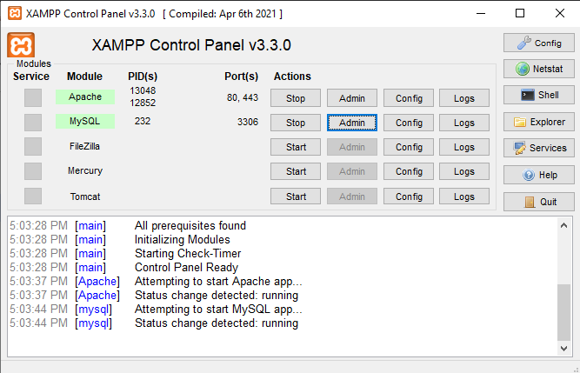

**Figure 6: XAMPP**

(Source: Made by self in XAMPP)

The first step in the development process involved setting up the establishment through the installation of Apache, PHP, and MySQL on a local computer with the help of XAMPP. The first development phase therefore involved coming up with the first order of structures and tables in the database and how they would be linked. After that the database was set up, and scripts in PHP language were created to deal with the form page and data processing (Zhang, 2021). The website was developed with a modularity concept to enhance the distinct separation between the client-side and the server-side interfaces. Undergoing a series of tests during the developmental stages of the database such as verifying database communications, form entries, and data downloads. There were minor changes done with reference to bug fixing and feedback to enhance the smooth functionality of the system. The last design was also tested and implemented into a local server for presentation of the final implementation.

# 5. Evaluation of Technologies Used

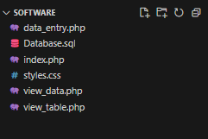

**Figure 7: Files used in the project**

(Source: Made by self in VS Code)

Its choice is explicable by such factors as PHP & MySQL compatibility, relative easiness of their integration, and reasonable price compared to the similar performances of Microsoft SQL Server or Oracle. MySQL has several advantages over other systems, as it is open source, and therefore, free of additional costs of licenses for scaling up the reach of the database. The server-side scripting of PHP makes it relatively easy to interact with the database in terms of accepting and processing data. There are other frameworks such as ASP.Net where a technologist can program the web application; however, PHP is more portable and unrestrictive than most of the frameworks that are available in the market. As PHP integrates well with MySQL, installing and managing both on any platform is fairly easy. This stack makes the system solid, dependable to avoid any hack, and scalable in a way that it can incorporate future enhancements.

# 6. Conclusion

This research found that effective executive implementation of a digital database system in a school like St Alphonsus Primary School is both convenient and effective in improving data organization over paper-based records. The functional and laminated design of its layout provides for ease of use in the administrative functions on the same without compromising on the quality and security of the data obtained. These can be enhanced through user identification and rights management to access the system to add to the security interest.

# 

Hidayat, R., 2020. Web-Based Examination System Using PHP and MySQL Accessed by Multiple Devices. AIP Conference Proceedings, 2591(1), p.030048. ​ https://www.researchgate.net/publication/369645862_Web-based_examination_system_using_PHP_and_MySQL_accessed_by_multiple_clients

Huang, Y. and Bringula, R., 2023. Design and Implementation of the Heartful Education System Platform Based on PHP. International Journal of Information and Education Technology. ​ https://www.ijiet.org/show-195-2619-1.html

Zhang, Y., 2019. Design of Educational Administration Comprehensive Information Platform Based on PHP and MySQL. In: Proceedings of the International Conference on Application of Intelligent Systems in Multi-modal Information Analytics. Springer, pp. 13-20. ​ https://dl.acm.org/doi/abs/10.1145/3503161.3548203

Zhang, Y., 2021. The Practice of MySQL in Realizing the Background Data Management of the Hybrid Teaching Management System. In: Proceedings of the International Conference on Application of Intelligent Systems in Multi-modal Information Analytics. Springer, pp. 579-586. ​ https://search.proquest.com/openview/5ac988d46281e72d642326b668c25469/1?pq-origsite=gscholar&cbl=18750&diss=y